NANOTECHNOLOGY IN CANCER TREATMENT

- INTRODUCTION
- Nanotechnology
- Cancer and Nanotechnology
- Benefits of Nanotechnology for Cancer
- Detection and Diagnosis
- Sensing In Vitro
- Imaging in Vivo
- Measuring Response to Therapy
- Treatment and Therapy
- Delivering Chemotherapy
- Delivering or Augmenting Radiotherapy
- Nano-enabled Immunotherapy
- Delivering Gene Therapy
- Problem and solution
- Conclusion

- INTRODUCTION :-
Cancer is a group of diseases marked by uncontrolled cell growth and invasion. Its causes include environmental factors such as radiation, pollution, and lifestyle habits like smoking, poor diet, stress, and inactivity, while only 5–10% of cases are due to inherited genes. Mutations in proto-oncogenes, tumor suppressor genes, and DNA repair genes are central to its development. Aging also increases susceptibility. Globally, cancer is the second leading cause of death, with about 1.9 million new cases reported in 2021.
To address these challenges, nanotechnology-based therapies have emerged as a promising approach. Nanoparticle drug delivery systems enhance drug targeting, reduce toxicity, improve pharmacokinetics, and overcome resistance. Since 2010, several nanotherapeutic drugs have reached clinical use, reflecting progress in precise and effective treatment. Overall, nanotechnology offers a hopeful path toward safer, more efficient, and personalized cancer therapies for the future.
Traditional treatments—surgery, chemotherapy, radiation, immunotherapy, targeted therapy, and hormone therapy—help control cancer but often cause severe side effects including fatigue, hair loss, neuropathy, and organ toxicity. Targeted and immune-based therapies have improved precision yet face limitations such as multidrug resistance, autoimmune reactions, and reduced effectiveness in solid tumors due to dense extracellular matrices.
- Nanotechnology
The Division of Cancer Treatment and Diagnosis (DCTD) supports research of established and emerging nanotechnology methods aimed at advancing cancer prevention, diagnosis, and treatment. Nanotechnology, which utilizes nanoparticles and nano-devices typically one hundred to ten thousand times smaller than human cells, enables researchers to address critical cancer-related challenges, such as developing diagnostic devices and sensors in vitro and achieving effective drug delivery to cancer targets in vivo. Significant progress has been made in implementing nano-based cancer therapies and diagnostics in the clinic, with many more interventions under development.

- Cancer and Nanotechnology
Nanotechnology involves manipulating matter at the nanoscale (1–100 nanometers) to create specialized structures and devices with significant applications in cancer research and treatment. At this tiny scale, materials exhibit unique properties that can be utilized for developing advanced diagnostic tools, targeted therapies, and preventive measures. These nanoscale structures can function independently or be integrated into larger systems, offering great potential in oncology and healthcare. Although research in nanotechnology began only in the 1980s, it has rapidly advanced, leading to promising nano-based therapies and diagnostics already being used in clinical settings, with many new developments currently underway to improve cancer care.
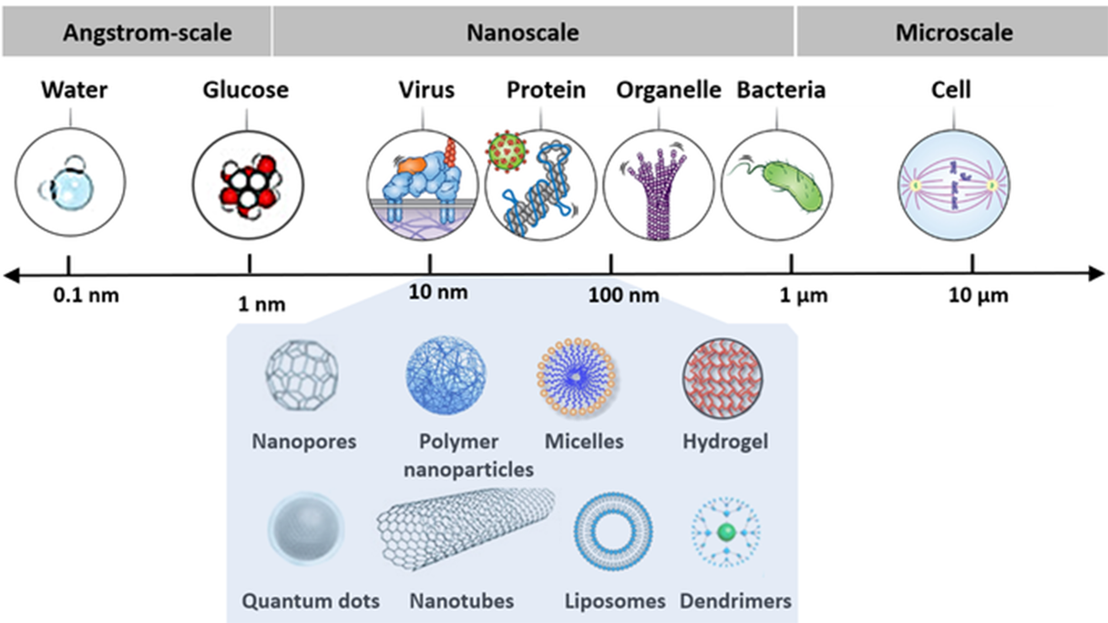
Nanoscale devices are incredibly tiny, ranging in size from one hundred to ten thousand times smaller than human cells. The depiction displays a portion of this scale in size. Adapted from Yicong Wu and Hari Shroff, Histochemistry and Cell Biology, 2022.
Credit: National Cancer Institut
This emerging and exciting field unites scientists from diverse disciplines, including physicists, chemists, engineers, information technologists, computer scientists, mathematicians, material scientists, and biologists. Nanotechnology finds applications in nearly every area of life, such as electronics, magnetics, optics, information technology, materials development, and biomedicine. Already, nanotechnology-based structures and devices are fueling numerous innovative applications in various fields, including the realm of medicine.
- Benefits of Nanotechnology for Cancer
Modern medicine has significantly improved outcomes in cancer management. However, the disease still causes over 600,000 deaths in the United States every year. While cancer treatments have advanced significantly, the need to increase their specificity and reduce systemic toxicity remains a challenge. As illustrated in the diagram below, nanotechnology presents opportunities to
(1) enhance earlier diagnosis through in vitro assays,
(2) enhance imaging capabilities for diagnosis and treatment monitoring,
(3) improve therapeutic outcomes by refining targeting precision, augmenting localized drug efficacy, and minimizing systemic toxicity.
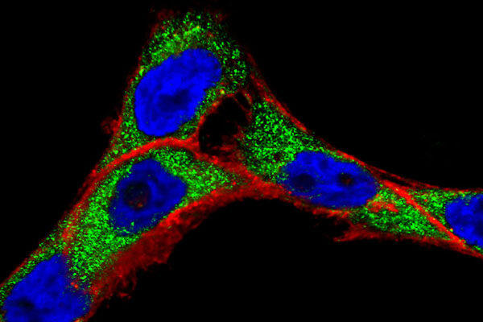

Progress in cancer nanotechnology requires a better understanding of how molecularly-targeted nanoparticles interact with live cells
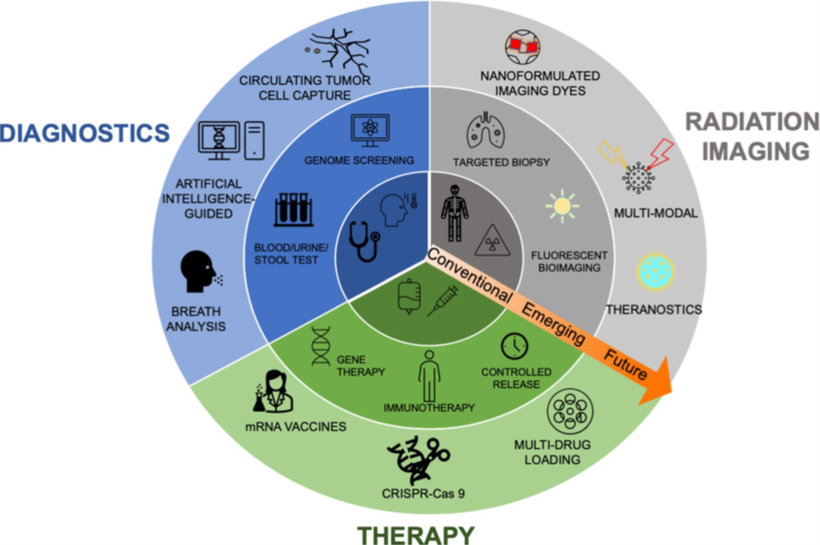
Conventional cancer therapies, diagnostics, radiation treatments, and imaging can be significantly improved through nanotechnological applications.
Source: Jessica A. Kemp and Young Jik Kwon, Nano Convergence, 2021
Nanoparticles, being 100 to 10,000 times smaller than human cells, can interact with biomolecules both on cell surfaces and within cells, offering broad access across organs. This unique property enhances cancer detection and treatment. Their design flexibility allows for precise targeting and rapid identification of cancer-related molecules, even in small cell populations. Gold nanoparticles, for instance, can be modified with ligands to study interactions with live cancer cells. Nanotechnology also enables the development of novel therapeutic agents and helps overcome physiological barriers like the blood-brain and stomach linings. These capabilities make nanomaterials promising tools for improving cancer diagnostics, treatment precision, and drug delivery, while reducing side effects and enhancing therapeutic outcomes.
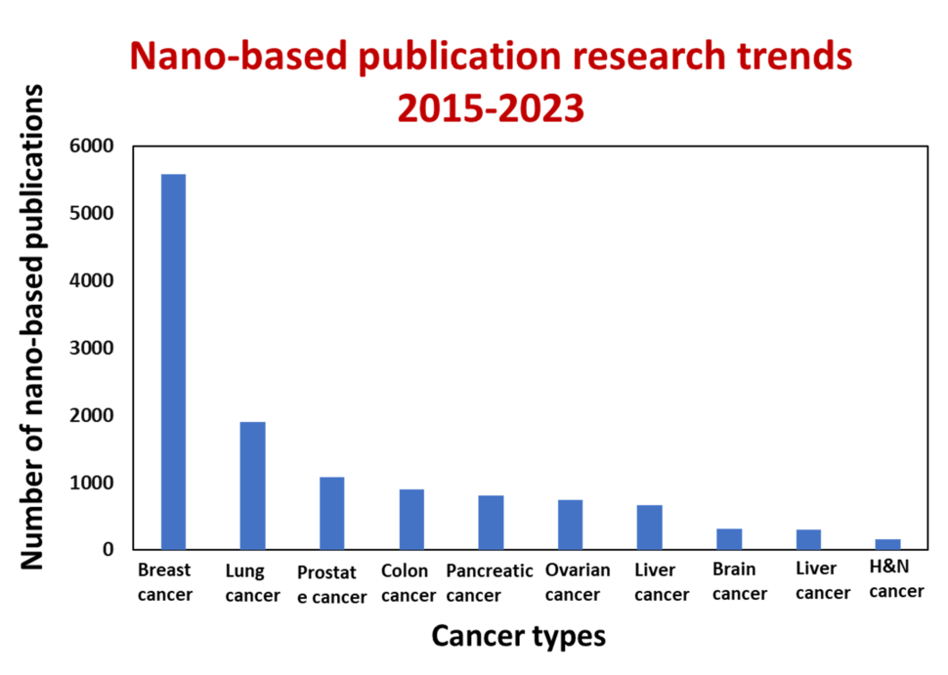
Nanotechnology-based interventions in different cancers. A 2015-2023 analysis using “nanoparticles” and “cancer type” search terms via iSearch. H & N: head and neck. Adapted from Carolina Salvador Morales and Piotr Grodzinski, WIREs Nanomedicine and Nanobiotechnology, 2023
Credit: National Cancer Institute

- Detection and Diagnosis
In the fight against cancer, half of the battle is won if it is diagnosed early. Identifying cancer in its early stages leads to a significantly higher 5-year survival rate. Early-stage cancer also typically requires a less aggressive treatment course. Current cancer care involves classic imaging techniques and morphologic analysis of tissues or cells. These techniques have limited capacity for achieving early diagnosis of cancer. Nanotechnology has the potential of providing new molecular contrast agents and in vitro assays to enable earlier and more accurate initial diagnosis. They can also be used for ongoing monitoring of cancer patient treatments. This is illustrated in the diagram below.
Nano-enabled biosensors (see image at right) exhibit exceptional sensitivity and specificity. They have the capacity to recognize multiple molecules, which enables them to detect extracellular cancer biomarkers like cancer-associated proteins, circulating tumor DNA, and extracellular vesicles. Nanomaterials come into play for the sensitive detection of cancer cells. For example, the isolation and characterization of circulating tumor cells (CTCs) is challenging due to their relatively low abundance. In order to more precisely detect CTCs, diverse nanomaterials are being developed and studied. Magnetic nanoparticles, nanowires, and dendrimers can be employed for this purpose. Additionally, nanoparticle probes accumulate within tumor tissues, so they can serve as contrast agents for in vivo cancer imaging, enhancing anatomical structure visualization. Nanotechnology-based approaches can also play a crucial role in measuring therapy response and optimizing treatment strategies.

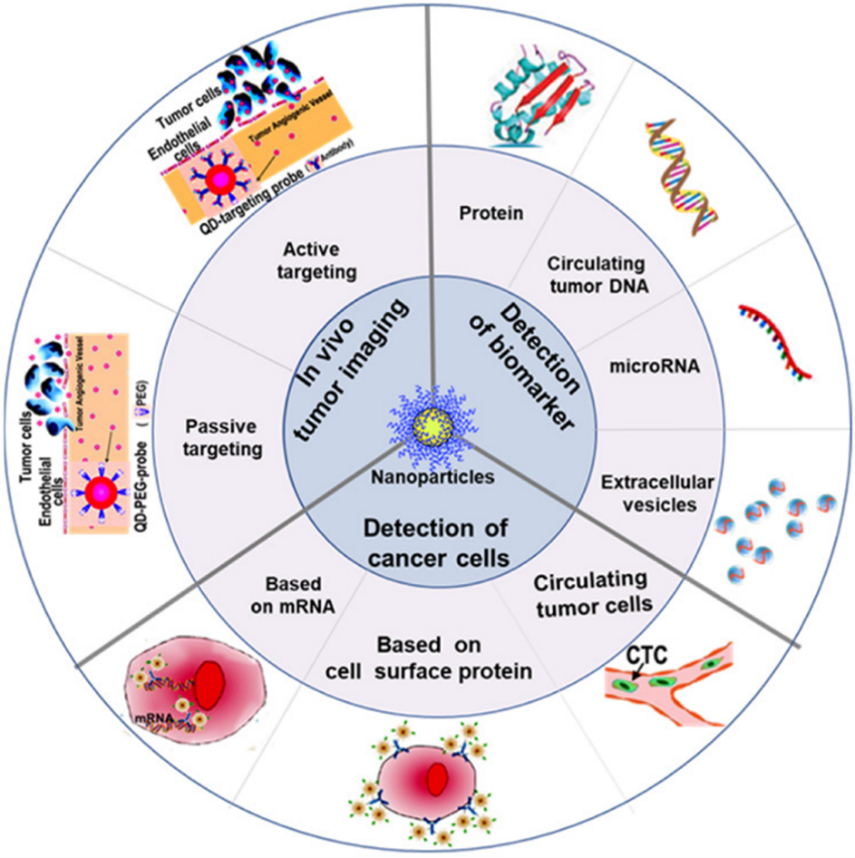

Schematic illustration of nanotechnology applications in cancer detection and diagnosis
- Sensing In Vitro
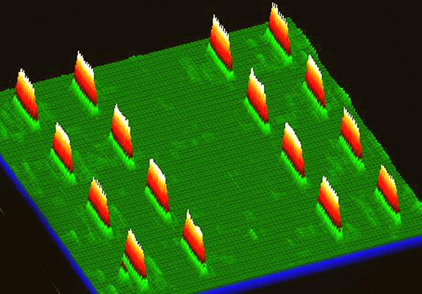
The discovery of cancer-associated molecular alterations has led to new opportunities for early cancer detection. These alterations are found in the blood by employing genomic, epigenomic, transcriptomic, proteomic, and metabolomic assays. Nanotechnology-enabled liquid biopsy diagnostic devices make it possible to enrich for blood-circulating ‘cancer fingerprints’ and then perform omics analyses. Through well-established fabrication techniques, such as lithography, compact devices or point-of-care systems are crafted. These diagnostic tools use biochemical reactions to interrogate the presence, activity, or concentration of specific biological molecules in a bodily fluid sample. These reactions, such as antigen-antibody binding, hybridization of DNA fragments, or ligand adhering to cell surface epitopes, can subsequently be transformed into measurable detection signals using methods like optical, magnetic, or electronic means.
DEAL Barcode Assay to Enable Precision Medicine. The image shows the DEAL (DNA-encoded antibody library) barcode assay, a high-density test for human blood proteins. It is designed to reveal unique disease markers, allowing for a precision medicine approach to treatment.
Nanoparticle-based diagnostic devices are being developed for detecting various cancers. A key example is an ultrasensitive bio-barcode assay for prostate-specific antigen (PSA), which can detect PSA at extremely low (attomolar) levels—far more sensitive than standard clinical tests. This assay uses magnetic nanoparticles with PSA antibodies and DNA-tagged gold nanoparticles in a sandwich immunoassay format. Elevated PSA levels can then guide PSMA-targeted PET imaging for prostate cancer diagnosis and treatment monitoring. Another approach, the DEAL technique, uses DNA-coded antibody libraries in microfluidic channels, converting DNA microarrays into antibody microarrays. This allows multiplex protein detection and blood analysis on small chip-based systems. Advances combining microfluidics and nanoscale materials are expected to enable highly detailed, in vitro cancer diagnostics from minimal patient samples.
- Imaging in Vivo
he sensitivity of current imaging methods, such as MRI, PET, and CT, can only detect cancers once thousands of cancer cells have grown. By this time, the cancer may have spread. Nanotechnology-based imaging contrast agents are being developed and translated for conventional imaging modalities. These offer the ability to specifically target and significantly amplify the detection of tumors in vivo. Current nanoscale imaging platforms enables novel imaging modalities that are not traditionally used for clinical cancer treatment and diagnosis. Examples include photoacoustic tomography (PAT), Raman spectroscopic imaging, and multimodal imaging (i.e., contrast agents designed for several imaging modalities at the same time). Nanotechnology makes these sensitive imaging platforms possible. Nanoparticles are designed to carry multiple components, such as conventional contrast agents and ligands, to target tumor cells.
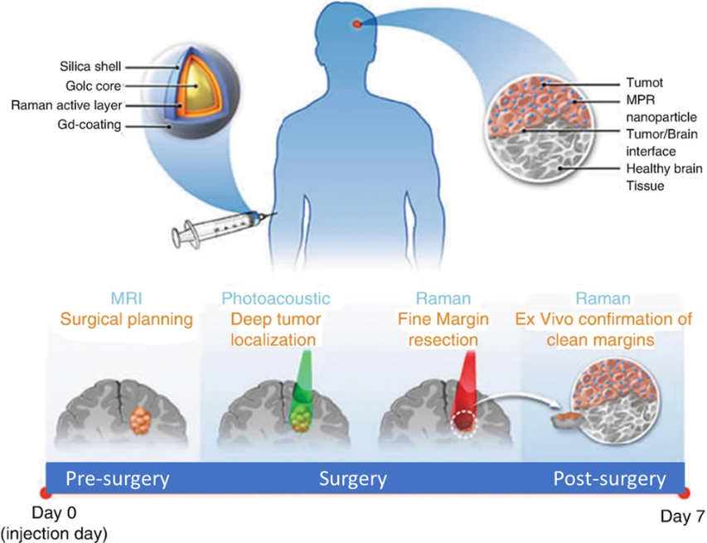
NCI-funded research has developed advanced nanotechnology-based imaging agents that enhance cancer detection and surgical precision. Multimodal nanoparticles enable visualization of brain tumors at the single-cell level using MRI, PAT, and Raman techniques, improving surgical accuracy. Additionally, silica-hybrid nanoparticles (“C-dots”) function as dual PET and optical imaging contrast agents and have shown effectiveness in targeting metastatic melanoma in clinical trials.
Principle of a triple-modality MRI-photoacoustic-Raman imaging nanoparticle
- Measuring Response to Therapy
The cornerstone of precise and prognostic medical care lies in measuring an individual patient’s response to targeted therapy, immunotherapy, or surgery as their disease progresses. Accurate and relevant monitoring of disease progress can allow providers to optimize treatment regimens. Treatment can be optimized through therapeutic course correction, use of drug combinations, and fine-tuning drug doses. Prognostic methods are essential for preemptive clinical decision making, such as separating patients who respond to therapy from those who do not. It is also used to stratify patients for clinical trials. In vivo imaging, tissue biopsy, and in vitro diagnostics are suited to this purpose. It is important for oncologists to be able to track cancer cell death in vivo. It enables them to deliver effective dosing regimens and/or precisely administer novel therapies. For example, scientists have designed a target-enabled in situ ligand assembly (TESLA) nanoparticle system. In this system, nanoparticles can self-assemble within the body when cleaved by enzymes from therapy-induced cell death (Deju Ye, et al., Nature Chemistry, 2014). These nanoparticles also carry imaging contrast agents to monitor local tumor response to therapies.
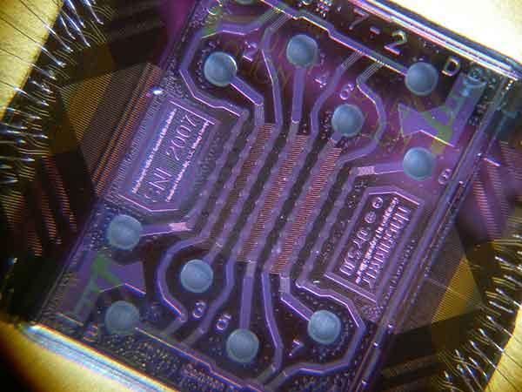
Multiplexed blood protein profiling via magneto-nano chip in vitro diagnostics.

- Treatment and Therapy
Nanotechnology in cancer treatment provides precise, targeted therapies that minimize damage to healthy tissues and enhance treatment effectiveness. Unlike traditional methods such as surgery, chemotherapy, or radiation, nanotech enables direct drug delivery to tumors, improved imaging for surgery, and reduced side effects. Nanoparticles can also carry multiple drugs, generate heat to destroy cancer cells, and be functionalized with antibodies or RNA for accurate targeting. Moreover, nanotechnology aids in developing immunotherapies and theranostics, integrating diagnosis and treatment for better outcomes. (Sources: He et al., Nature Communications, 2016; Irvine & Dane, Nature Reviews Immunology, 2020.)
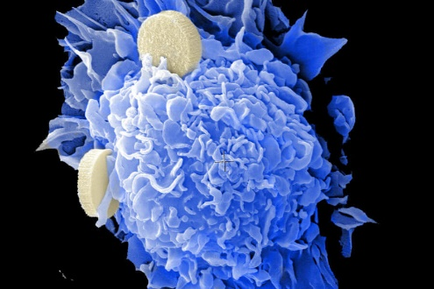
Novel vaccine delivery systems for cancer therapy.

- Delivering Chemotherapy
Nanotechnology enhances cancer therapy by improving drug delivery and reducing chemotherapy toxicity through targeted nanoformulations. These nanosized carriers use the enhanced permeability and retention (EPR) effect to accumulate in tumor tissues, allowing precise drug delivery and minimizing harm to healthy cells. Controlled release can be triggered by pH, heat, or ultrasound. Researchers are advancing nanomaterial-based therapies, including photodynamic treatment for bone marrow cancers and nanoparticle systems that overcome biological barriers for targeted chemotherapy. Such innovations promise more effective, safer cancer treatments.
(Sources: Zheleznyak et al., WIREs Nanomedicine and Nanobiotechnology, 2018; Meng et al., ACS Nano, 2015)
- Delivering or Augmenting Radiotherapy
Nanotechnology is revolutionizing radiation therapy by improving precision and minimizing side effects. While traditional radiotherapy kills cancer cells using X-rays or gamma rays, it also harms healthy tissue. Nanoparticles with high atomic numbers enhance radiation absorption, boosting tumor destruction while allowing lower doses. Some nanoparticles release drugs or generate reactive oxygen species (ROS) when exposed to radiation, enabling targeted and combined treatments like photodynamic therapy (PDT). These innovations enhance treatment effectiveness, reduce toxicity, and help overcome radiotherapy resistance in cancer cells.
(Sources: Her et al., Advanced Drug Delivery Reviews, 2017; Chen et al., Nature Nanotechnology, 2019)
- Nano-enabled Immunotherapy
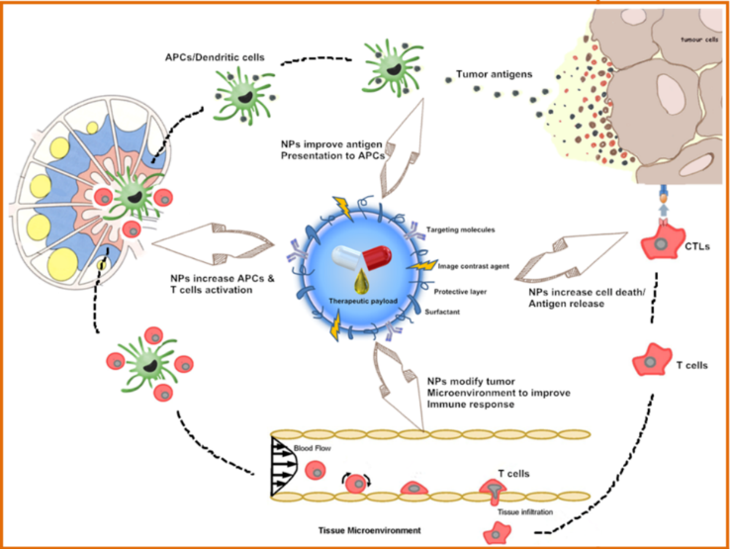
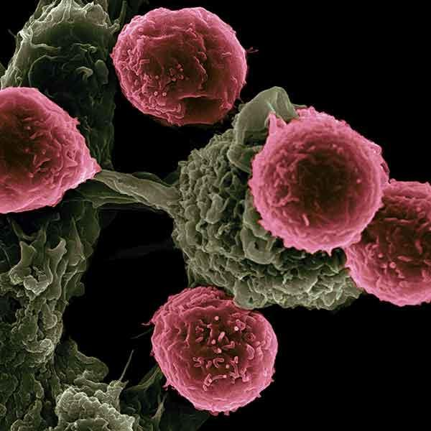
Nanotechnology is transforming cancer immunotherapy by enhancing precision and minimizing side effects. Traditional immunotherapies, such as checkpoint inhibitors and cancer vaccines, can trigger autoimmune or inflammatory reactions. Nanoparticles help regulate immune responses by enabling targeted delivery of immunostimulatory molecules and vaccines, reducing toxicity. They can also capture tumor antigens released after therapy and promote strong T-cell activation through controlled antigen release. Additionally, nano-enabled platforms improve immune cell analysis and imaging, aiding personalized treatment. These advancements make immunotherapy safer and more effective.
(Sources: Irvine & Dane, Nature Reviews Immunology, 2020; Park et al., Nature Materials, 2021

Vaccine-based immunotherapy from novel nanoparticle systems. This scanning electron microscope image shows dendritic cells, pseudo-colored in green, interacting with T cells, pseudo-colored in pink. The dendritic cells internalize the particles, process the antigens, and present peptides to T cells, guiding immune responses.

- Delivering Gene Therapy
Nanotechnology greatly enhances nucleic acid–based cancer therapies by protecting unstable genetic materials like siRNA, mRNA, and miRNA from degradation and improving their delivery to tumor sites. Nanocarriers extend the lifespan and effectiveness of these therapeutics while enabling controlled release for targeted gene regulation. Current research focuses on using spherical nucleic acids (SNAs) for brain cancer treatment and siRNA-loaded nanoparticles to overcome drug resistance in melanoma. These advancements make gene-based cancer therapies more stable, precise, and efficient.
(Sources: Kumthekar et al., Science Translational Medicine, 2021; Zhao et al., Nature Communications, 2016; Guo, Nature Nanotechnology, 2010)
- Problem and solution
- Problem 1: Lack of Targeted Drug Delivery
Traditional chemotherapy affects both cancerous and healthy cells, causing severe side effects and limited effectiveness. Drugs often fail to reach tumors in sufficient concentrations due to biological barriers. Nanotechnology solves this by enabling targeted drug delivery using nanoparticles that accumulate in tumors via the enhanced permeability and retention (EPR) effect. Functionalized nanoparticles can carry drugs directly to cancer cells, minimizing systemic toxicity and improving treatment outcomes. This precision reduces side effects while maximizing therapeutic efficiency.
🔗 Source: National Cancer Institute (NCI)
- Problem 2: Drug Resistance in Cancer Cells
Drug resistance is a major barrier in cancer therapy, leading to relapse and treatment failure. Cancer cells can adapt, pump out drugs, or mutate target proteins. Nanotechnology addresses this by enabling co-delivery of multiple drugs and genetic materials, such as siRNA, to silence resistance genes. Nanocarriers can bypass drug efflux pumps and release drugs in a controlled manner directly inside resistant cells. These smart systems enhance drug accumulation and restore sensitivity to chemotherapy, offering renewed hope for resistant cancers.
🔗 Source: Nature Reviews Drug Discovery
- Problem 3: Early Detection and Diagnosis
Early cancer detection is critical but often limited by poor imaging sensitivity and non-specific biomarkers. Nanotechnology provides advanced diagnostic tools through nanoscale contrast agents that improve MRI, CT, and fluorescence imaging accuracy. Quantum dots, gold nanoparticles, and magnetic nanomaterials can detect tumors at much earlier stages by binding to cancer-specific molecules. These nano-based biosensors and imaging agents allow real-time monitoring, enhancing precision and early intervention possibilities in cancer management.
🔗 Source: ACS Nano
- Conclusion
Nanoparticles (NPs) hold remarkable potential in revolutionizing cancer diagnosis and treatment due to their ability to target specific cells, improve imaging precision, and deliver drugs effectively. Despite these advantages, several critical challenges must be addressed before NP-based therapies can be fully integrated into clinical practice. One major limitation lies in achieving high specificity and sensitivity for early cancer detection—many nanoprobes still face difficulties distinguishing cancerous cells from normal tissues. Moreover, optimizing nanoparticle pharmacokinetics and biodistribution remains a hurdle, as their size, shape, and surface properties significantly influence their biological interactions and accumulation in tumors.
Another key concern is the safe and controlled release of therapeutic agents. Researchers continue to develop smart nanocarriers responsive to stimuli such as pH, temperature, or enzymes, allowing site-specific drug release while minimizing systemic toxicity. However, large-scale manufacturing, reproducibility, and cost-effectiveness pose barriers to commercialization. Furthermore, understanding nanoparticle toxicity, long-term retention, and clearance from the body is essential for ensuring patient safety. Studies show that improper NP clearance may lead to unwanted accumulation in organs like the liver or spleen, raising potential toxicity issues.
To advance clinical translation, rigorous standardization of testing methods, reproducibility in synthesis, and clearer regulatory guidelines are required. Collaboration among material scientists, clinicians, and regulatory bodies will accelerate the safe adoption of NP-based cancer treatments. Continued exploration into biodegradable and biocompatible nanomaterials, along with the integration of artificial intelligence for nanoparticle design and personalized therapy, represents the next frontier in precision oncology. In summary, nanotechnology offers transformative promise for cancer care, but ensuring safety, consistency, and regulatory compliance remains vital for its successful clinical application.
Sources:
🔗 Nature Reviews Drug Discovery (2022)
🔗 ACS Nano (2021)
🔗 National Cancer Institute (NCI)

THE END

